Raising Broilers and Roasters as 4-H projects

Raising broilers or roasters is an excellent starting point for most poultry project members. The chicks are relatively readily available, inexpensive, and easy to raise in a short period of time with very limited facilities.

Getting Started

The first step in a broiler/roaster project is to make sure that the municipal ordinances where you live will allow you to raise chickens of any kind. Property that is zoned Agricultural should have no restrictions on raising a small poultry project. Many cities now have variances that allow residents to raise a small number of birds specifically for a 4-H projects. Suburban subdivisions may also have deed restrictions on the number and kind of animals that residents may have. Check with your local officials to be sure. This is a good lesson in citizenship as well as being courteous to your neighbors.
Even if your locality does not allow you to raise them on your property, there are ample opportunities to raise your birds cooperatively with another project member that lives where there are no restrictions. Since a broiler project is only 6 weeks long, an agreement could be made with a nearby farm-owner to use facilities for raising your birds. Such agreements, if properly completed, could lead to expanded projects and even employment opportunities!

Equipment and facilities

The equipment and facilities that are necessary to raise broilers or roasters are the same as for any poultry. An adequate water supply, typically a one-quart waterer at first and a gallon-sized or larger waterer is appropriate as they grow (depending on how many birds are part of your project). Fresh, clean water is essential for proper chick health and growth.
Simple chick feeders are used at first, but a larger feeder will be necessary as the chicks grow. Keep in mind that these birds will double their size in only a couple of days and will continue to grow rapidly through their first six weeks. They will need increased amounts of daily water and feed supply.
Brooding may be done in a facility as simple as a large cardboard box with a heat lamp suspended about two feet above the floor. The best option for a brooder box is a large plastic tote with a heating plate. Both options are acceptable and have different benefits. For the first week it is best to use a none slip surface on the bottom of the brooder box to help prevent splay or spradle leg. Some members have used puppy pads with paper towel over top of them. After the first week, wood shavings may be used as bedding, but must be kept clean and dry. The main reason we don’t use pine shavings in the first week is that the chicks are unable to grind and process the pine shavings in their crop yet. Again, it must be stressed that these birds are bred for rapid growth and cleaning their brooder will be necessary quite often. More elaborate brooders with hardware cloth floors may be used, if desired and available, but make sure that the chicks toes will not get caught in the floor. The temperature at chick level should be 95 degrees F for the first week and decreased 5 degrees for each week after that.
Chicks do not tolerate drafts. Solid sides to the brooder or draft-free housing should be provided. Adequate fresh air and ventilation is essential to prevent respiratory disease.
As the birds grow, additional space should be provided. Small numbers of birds (4-5) can be grown out in a large rabbit cage suspended several inches from the floor. This will insure a dry environment for the birds. Larger numbers of birds can be allowed to range freely on grass or on the ground in a cage that is moved frequently throughout the day.
Proper shade and cooling is also essential for older birds as heat is for the babies. Never leave your birds in the hot summer sun without the opportunity to escape to a shady cool area. Today’s fast-growing, large, muscular meat birds cannot tolerate over-heating for long.

Source of chicks

There are a number of commercial hatcheries that can provide hybrid meat-type chicks and are sold through catalog orders and delivered by mail. Many local feed suppliers team up with hatcheries that deliver chicks directly to the store. Pre-order your chicks so that broilers arrive approximately 42 days and roasters arrive 56-70 days before show day. Environmental factors (such as extremely hot summer temperatures) could affect the growth of your birds.
Making multiple order of chicks + or – a few days will assure a range of birds that will be properly finished for your show day.

Feed

Commercial feed suppliers produce quality feeds. A typical chick starter feed will get your birds growing from day one. A finishing ration will provide the nutrition necessary to insure proper muscling and fat at the end of the project. A crumble feed will maximize growth and feed efficiency. Consult your feed dealer, local feed mill, superintendent or older project member for recommended rations.
Some project members remove the feeders each night, returning them early the next morning. Though growth might be slowed slightly, evidence shows that the birds, especially males, will be structurally more sound at show time due to growth while standing, rather than sleeping. Typically, it will only take about 2 pounds of feed per pound of growth for broiler-type chickens. Keep in mind that your broilers will eat about 10 pounds of feed from start to finish, so you don’t want to purchase extra feed. The feed efficiency of roasters is less than broilers.
Some project members are surprised to find that these chicks eat a lot of feed in a short period of time and grow very rapidly. This means that they will also produce a lot of manure that should be cleaned frequently to maximize growth. Cleanliness during the entire growing period is essential to having a clean-white bird on show day.

Growing Period

Because of their genetics, rapid growth and warm summer-time weather, your chicks will seem to grow faster than their feathers! Often they will appear half naked for most of their growing period. This is normal and you should not be concerned. Your birds are bred and fed for meat production! A full cover of feathers would reduce feed efficiency and might indicate cooler than normal growing temperatures or some other decreased growth factor.
Weighing your birds and charting their growth daily is a good way of understanding the growth cycle of a broiler or roaster. Broilers will typically double their weight in their first couple days of life and will gain as much as one and a half to two pounds in the last week.

Getting Ready for Fair

If you have managed your birds properly from the start through the growth period your birds should be in great shape for your fair. Select your show birds carefully according to the criterion explained below. Make sure that you know the proper procedures for entering your birds in the fair and have the proper health documents that are necessary for making an exhibit. For example, pen finances, and NPIP certificate form the hatchery. Learn from your leaders and older project members the proper methods of handling your birds and showing them. A few days before fair, it is a good idea to bathe your birds to make sure they are clean for check-in day. Give yourself plenty of extra time on show day so that your birds will be ready and do their best. Listen to the judge’s comments and learn how to improve your project.
Take good care of your birds during the fair. Keep them clean, watered and fed the same ration that you use at home. Some will even bring water from home so that it tastes the same for the birds. Because county fair time is usually the hottest time of the year, do whatever you can to keep them cool.

Judging Meat Chickens

The criterion used for judging meat chickens is based on USDA Standards for Grading Poultry and animal husbandry practices.

Disqualifications-these factors would prevent the bird from being slaughtered for food purposes. Crippled or unable to stand and move normally, blind, crooked breast bone, breast blisters, broken bones, skin cuts, bruised flesh, illness and parasites (removed from the showroom by superintendent), absence of fleshing and finish (fat), objectionable dirt, staining and filth.

Properly fitted and groomed meat chickens are raised in immaculately clean conditions and are bathed prior to the show with oil applied to the combs, wattles, feet and legs prior to judging.

Desirable Market Factors

Proper age and weight for class

Broilers – weight is 3.5 lbs. to 6 lbs. Age is 42 days to 49 days

4-H projects typically give more range of weight and age than the industry standard
allows because of the wide number of uncontrollable factors for youth projects such as climate
conditions, date of delivery of chicks and population density.
Broilers should exhibit youthfulness determined by appearance and the lack of
molting of juvenile primary flight feathers. Chickens have 10 primary flight feathers. The
juvenile feathers are pointed at the ends. Molting typically begins at 42 weeks and continues
with 2-3 feathers per week until all 10 have been replaced with adult feathers. Birds that are
slaughtered prior to molting primary flight feathers produce the greatest amount of meat per
pound of feed consumed.

Roasters – weight is 6.5 lbs. to 8.5 lbs. Age is 56 days to 70 days

Though the 14 or 15 pound heavy roasting chicken is very impressive and niche
markets demand heavy birds, industry standards require a much lighter bird that is more
efficient in conversion of feed into meat. Heavy roasters often suffer leg problems. Roasters should exhibit more maturity than broilers (observed by the redness of
combs and wattles) yet should never be sexually mature and should still have numerous juvenile
primary flight feathers. Sexually mature birds have a low dressing percentage due to the loss of
inedible large reproductive organs and excessively large bones.

Conformation – Like all animals, meat chickens should be structurally sound. They need to walk on a proper set of feet and legs and move freely and easily. Obvious extremes in body shape and structure are undesirable and lack appeal.

Fleshing – The amount of muscling is determined by feeling the width of the breast and back particularly over the loin region. The breast meat is the most valuable cut of meat on the meat chicken. The width of the loin is an indicator of muscling throughout the carcass. The thickness of bone also indicates muscling due to the fact that the more muscling an animal has the larger the bone must be to hold the muscle. Excessive bone is not desirable because of decreased dressing percentage.

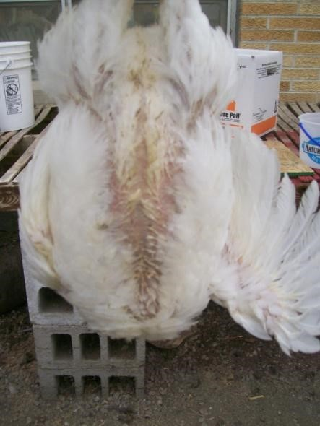
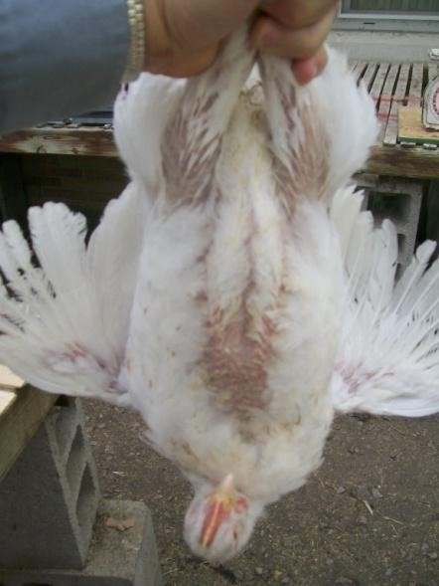

The breast meat is the most valuable part of the chicken. The bird on the left shows a broad breast with adequate amount of finish while the bird on the right lacks in overall width. The judge will handle each bird to determine the amount of meat in the breast, through the thigh and over the back.

Finish – Fat provides flavor and tenderness to meat. Adequate fat is desirable, yet excessive fat reduces feed efficiency, overall yield and dressing percentage. Pullets tend to fatten faster than cockerels due to the affects of the sex hormones estrogen and testosterone. Industry producers typically sex broiler chicks at a day-old and separate them, providing specific rations for each, reducing concern for excessive fat.

General appearance – As in other meat animal species, female chickens tend to offer more eye appeal than males because estrogen causes a rounder body structure, thus a meatier and more youthful appearance in the live animal. Therefore, project members are encouraged to raise pullets as broilers rather than cockerels. Pullet chicks are generally cheaper than cockerel chicks as well.

Pens

Like other meat animals, roasters are shown in pens. This exhibit is intended to determine if the exhibitor understands the basic principles of meat chickens. Pens are intended to be matched as closely as possible.
A pen exhibit simulates the industry’s need for uniformity in birds that ultimately produce a uniform product that the consumer demands.
A pen of meat animals are the same sex! This exhibit should be either all cockerels or all pullets. They should weigh nearly the same, have similar body structure, fleshing and finish. Matching a pen may be difficult when only a small number of birds are being raised. If one of the birds shows a disqualification or serious defect, then the whole pen will be marked down.
Since roasters purchased from one supplier have nearly identical genetics, the environmental factors in which a group of birds are grown have a tremendous impact on the bird that is produced.

Terminology
Broiler or Fryer – A young chicken, cockerel or pullet, approximately 42 days old. The two terms are interchangeable, having regional preference (Broiler – northern states; Fryer – southern states. Typically marketed at 4-5 pounds live weight and 3-4 pounds dressed weight. The meat of these birds is tender and lacks strong flavor.
Capon – male chicken that was castrated at 6 -12 weeks of age. Marketed at 20+ weeks of age, prized for flavorful meat with a high percentage of fat.
Cockerel – young male chicken
Heavy roasting chicken – Male of female meat-type chicken weigh 12-14 pounds live weight with some individuals even heavier! They typically dress an 8-11 pound carcass that must be cooked slowly at reduce temperatures in order to provide a desirable, tender entrée. A roasting chicken is more mature than a broiler, is larger and is cooked at a lower temperature for a longer time.
Pullet – young female chicken
Purebred – Animals that breed true to color, body shape and other physical features. There are over 300 recognized breeds of large fowl and bantam chickens.
Stewing Hen or Soup Chicken—A sexually mature chicken, typically one year or more old. These carcasses will produce a flavorful broth when cooked slowly by simmering in a pot of water. Flavor and cartilage is extracted from the muscle and bone, providing a soup stock. The small amounts of meat can be stripped from the skeleton and added back into the final dish. Spent hens, laying hens that have completed their laying cycle are often used for this purpose.
Young roasting chicken – Male or female meat-type chicken weighing 7-8 pounds live weight and 5-6 pounds dressed weight. Typically, these chickens are 8-10 weeks of age. The meat of these birds is tender and the meat is more flavorful than the broiler/fryer.

